# Dental CT

* Clinical indications:
  + Preoperative planning for bone augmentation.
  + Preoperative planning for sinus lift
  + Preoperative planning for site development
  + Preoperative planning for Dental implant
  + Evaluation of focal lesion
  + Postoperative imaging for implant mobility.
  + Postoperative imaging for altered sensation following surgery.
  + Postoperative planning for implant retrieval.
  + Evaluate for dental issues such as tooth decay, bone loss, abnormal growths, facial fractures, periodontal infections, irregularities of the temporomandibular joint and problems
  + Evaluate the sinuses and nasal cavity.
  + Others
* Technique/ Protocol:
  + Small FOV CBCT
  + Medium FOV CBCT
* Reporting:
  + Image processing:
    - Reorient data and format data.
      * Sagittal / Axial /Coronal
      * Forming accurate arc spline is important in constructing cross sections.
  + Observations:
    - Bone quality (Lekholm and Zarb in 1985) :



* + - * Quality 1: Homogenous compact bone (best quality): HU > 1250

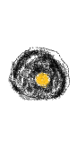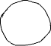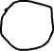

* + - * 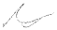Quality 2 : Thick layer of compact bone around a core of dense trabecular bone. HU 850-1250

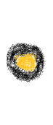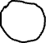

* + - * Quality 3: Thin layer of cortical bone around dense trabecular bone. HU 350-850
      * Thin layer of cortical bone around a core of low density trabecular bone (poor quality). HU 150-350

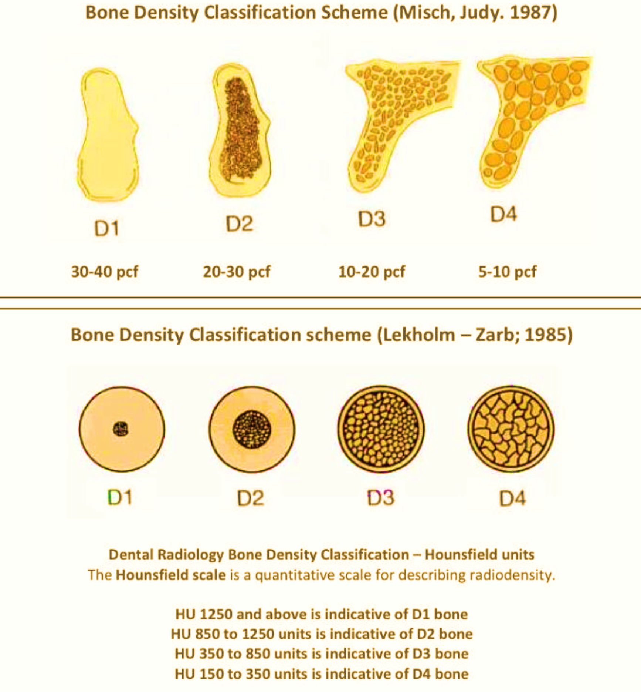

* Inferior alveolar canal:
  + Starts posteriorly at the mandibular foramen on the lingual plate. Runs anteriorly, forms a small loop before exiting at the mental foramen apical to 2nd premolar or between the bicuspids.

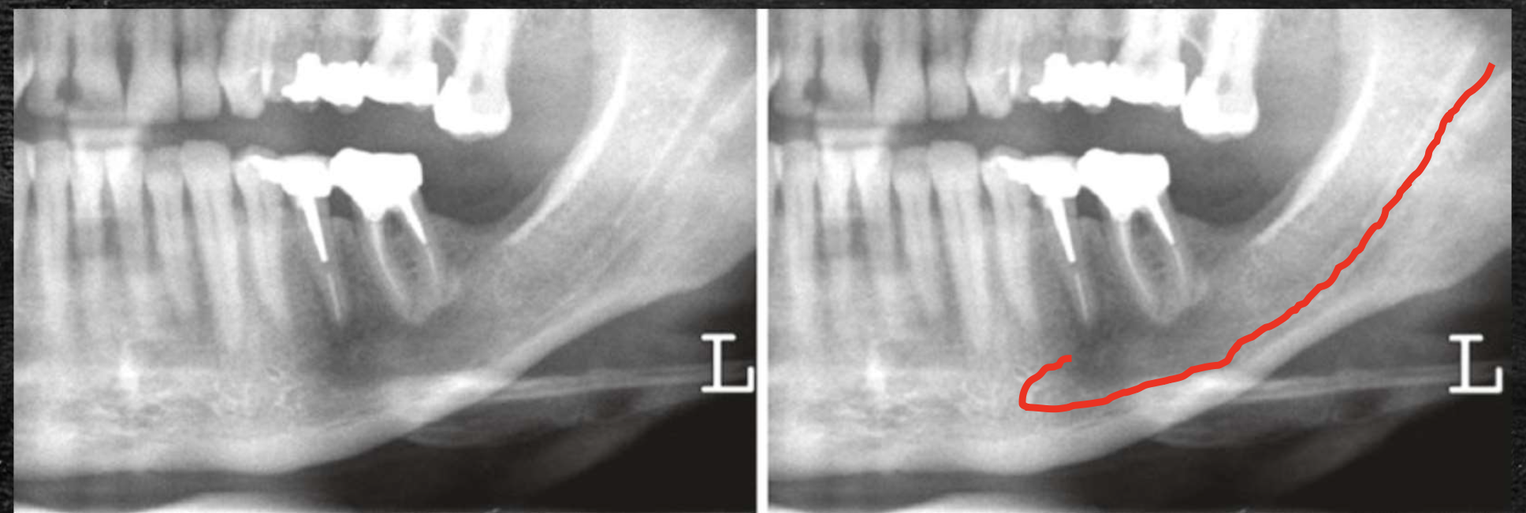

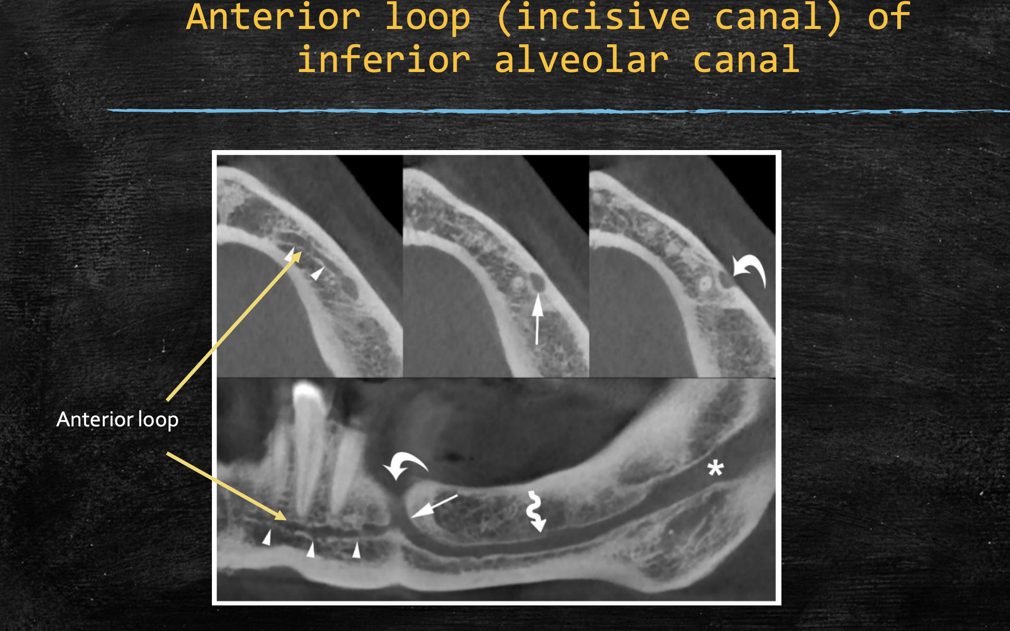

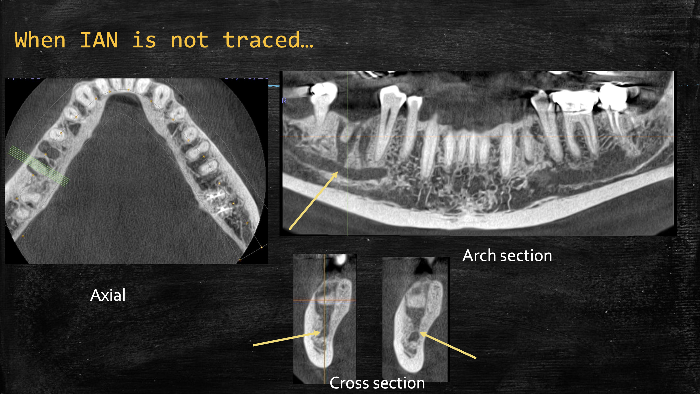

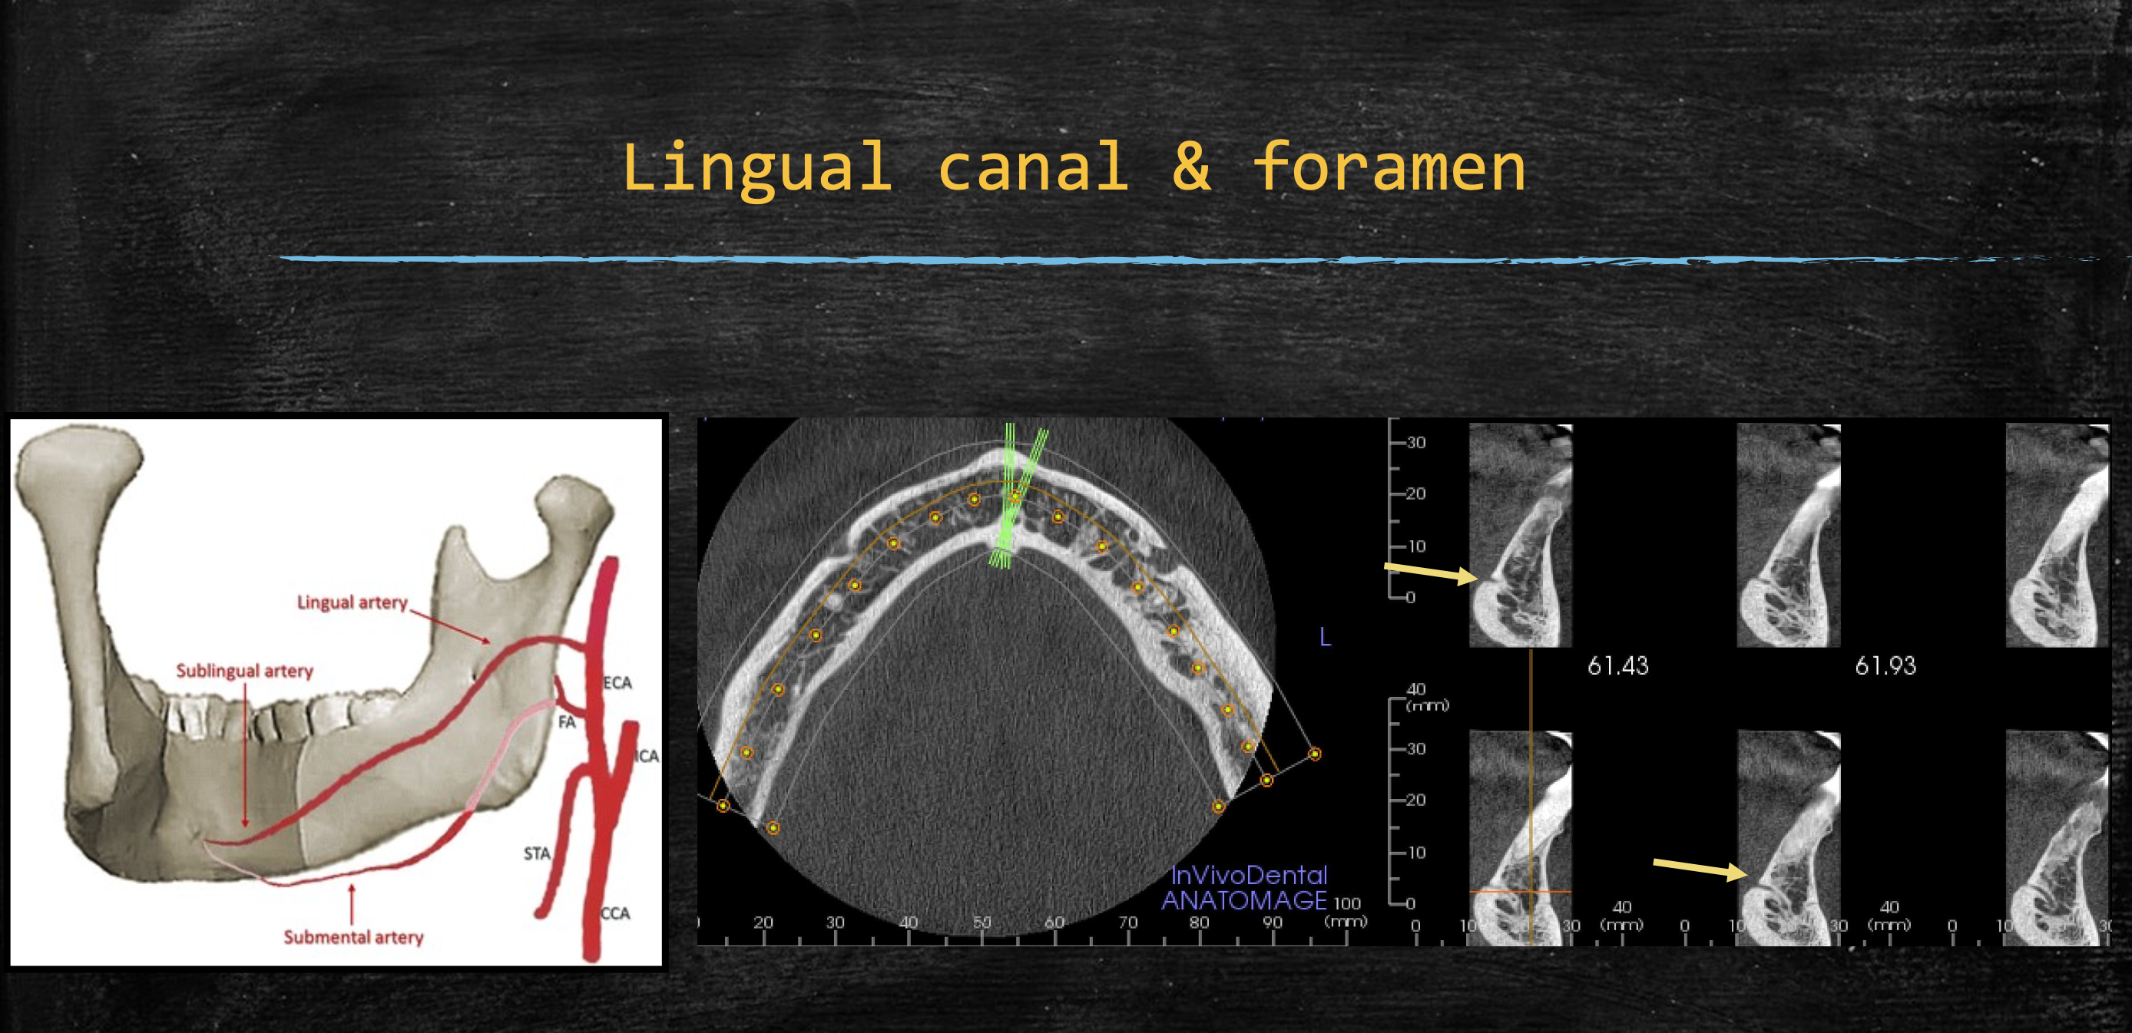

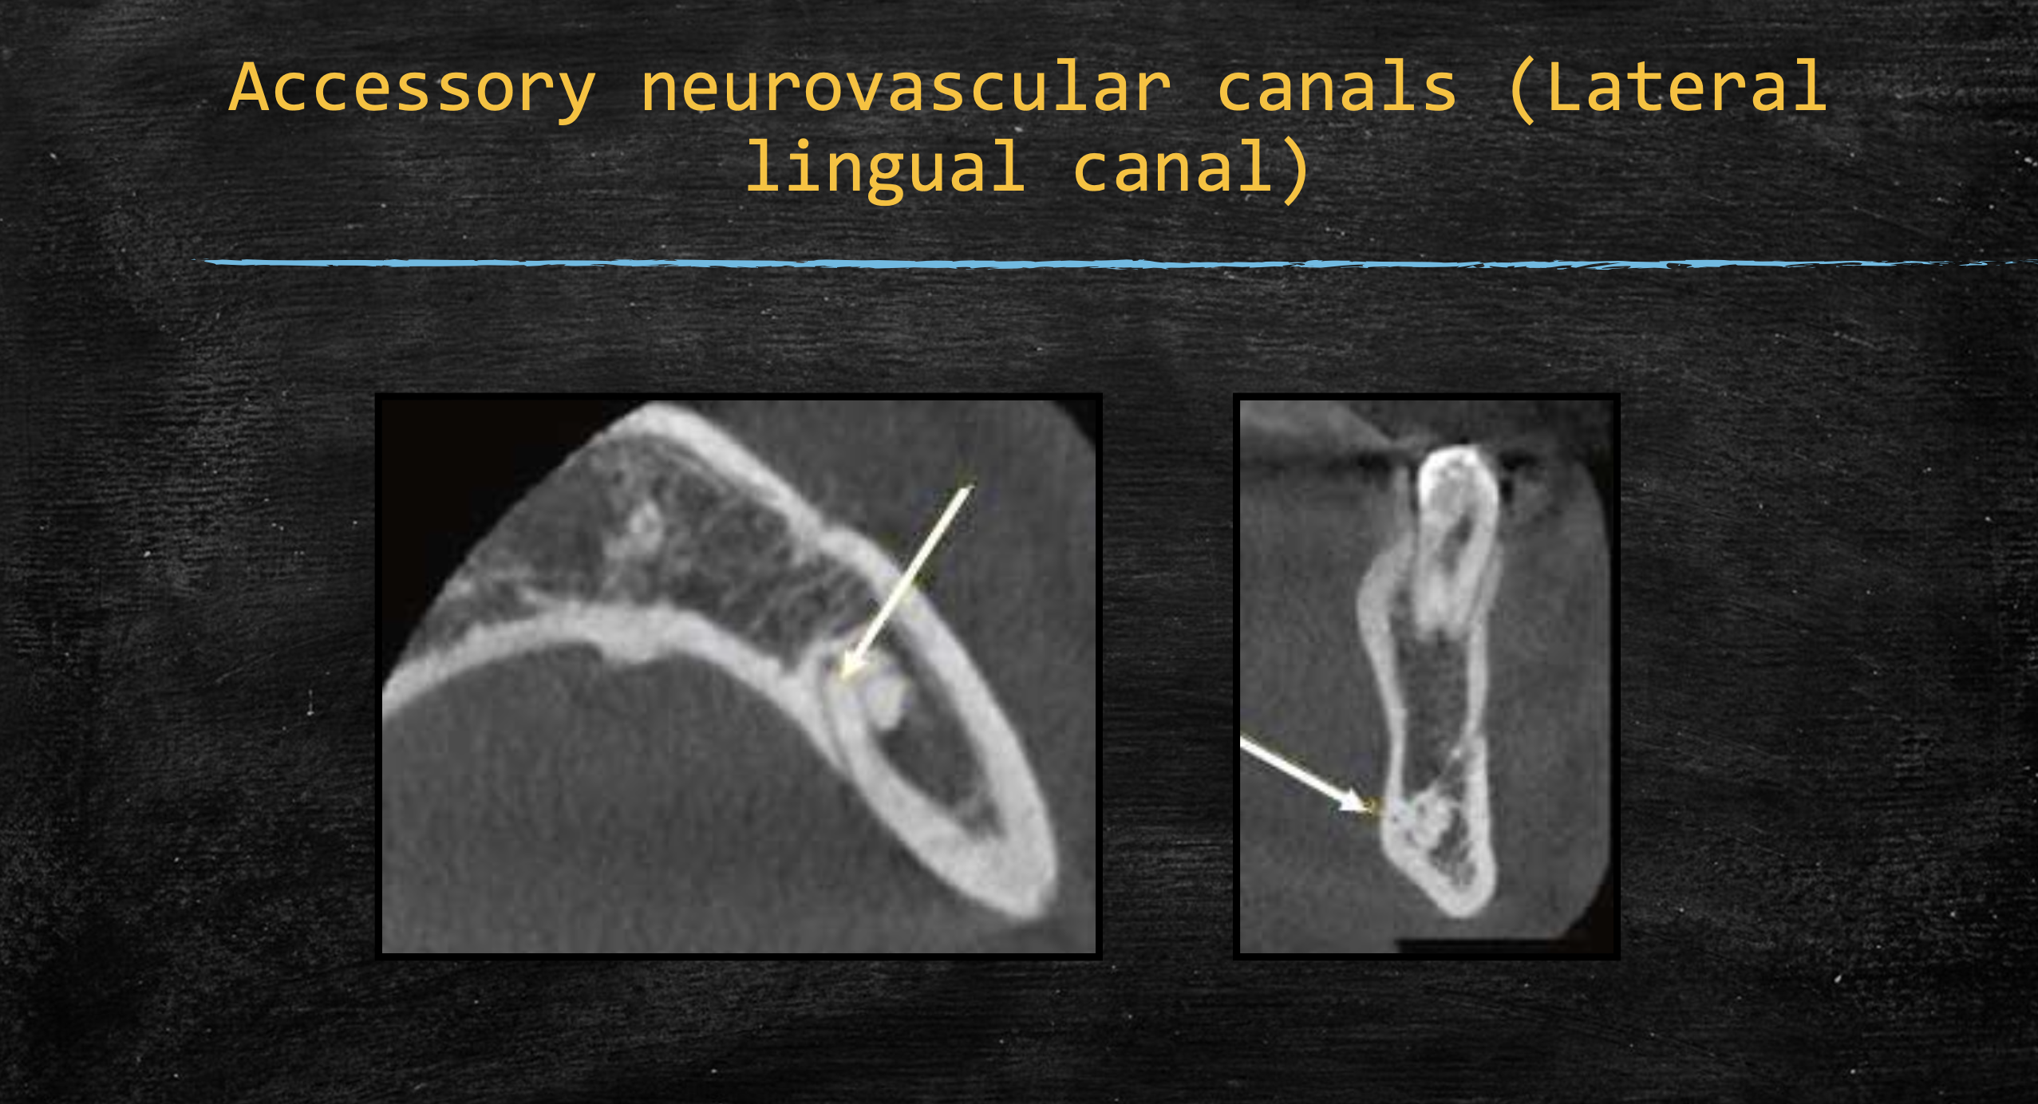

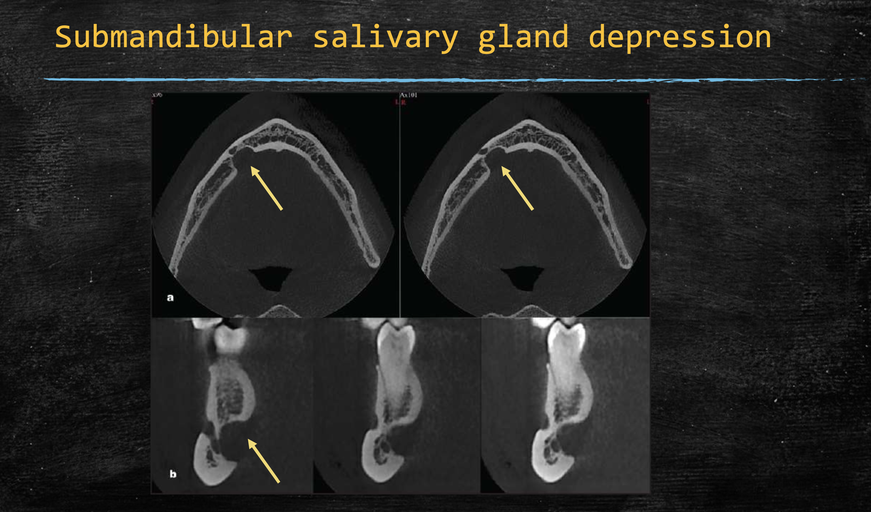

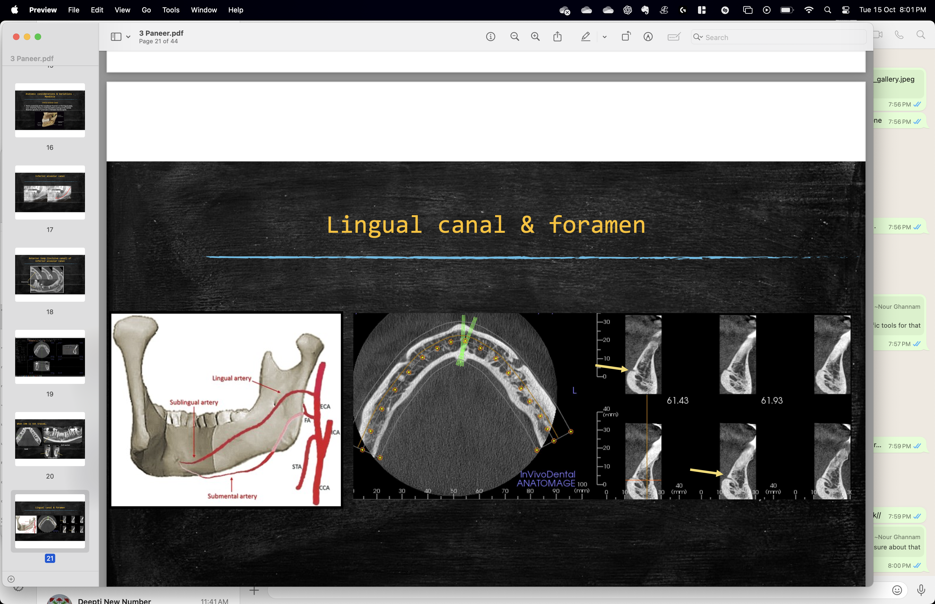

Retromolar canal and its varations :

* The retromolar triangle (RMT) is a depressed area formed by the bifurcation of the mandibular temporal crest and the posterior edge of the last mandibular molar.
* The gross anatomy of the RMT, which is an area of great importance in dental practice, varies greatly according to the presence of the mandibular third molar and alveolar bone resorption.
* The retromolar canal (RMC) normally arises from the mandibular canal behind the third molar, and travels anterosuperiorly to the retromolar foramen (RMF), which is located within or around the RMT.
* Several studies on the RMC and RMF have reported considerable diversity with a frequency from 1.7% to 72% depending on the study design and the race of the participants.
* Knowledge of the location of the RMC and of its anatomical variations can facilitate surgical intervention and protect the patient from the potential complications thereof.
  + The RMT is relevant to surgical procedures, such as extraction of an impacted third molar, dental implant treatment, bone harvesting as a donor site for bone graft surgery, and sagittal split ramus osteotomy.
  + Moreover, the content of the RMC is an issue of clinical concern in surgical procedures involving the RMT.
  + The neurovascular content of the RMC contains predominantly thin nerve fascicles of myelinated nerve fibers branching from the inferior alveolar nerve, small arteries, and numerous venules accompanying those arteries. Therefore, damage to the RMC contents could lead to un- expected bleeding and iatrogenic nerve damage, potentially resulting in paresthesia.
* In clinical practice, anatomical variations, such as sup-plemental or accessory canals and foramina, can only be detected by radiologic methods. However, conventional two-dimensional (2D) radiographs such as panoramic im- ages are insufficient for detecting all anatomical struc- tures, and in particular the presence of an RMC. Sectional imaging, such as computed tomography (CT) and cone-beam CT (CBCT), has been used successfully in dentistry and CBCT systems are available for routine investigation in dental clinics.

Summary : Anatomical variations in the form of the accessory foramina and canals of the mandible can cause surgical complica- tions if not properly identified. The RMC is a rare anatom- ical variation found in the RMT, which is a small, triangular- shaped region posterior to the third molar tooth in the mandible. The RMT was classified into three types (tapering, drop, and triangular forms) according to its shape, as described previously in part by Suazo et al

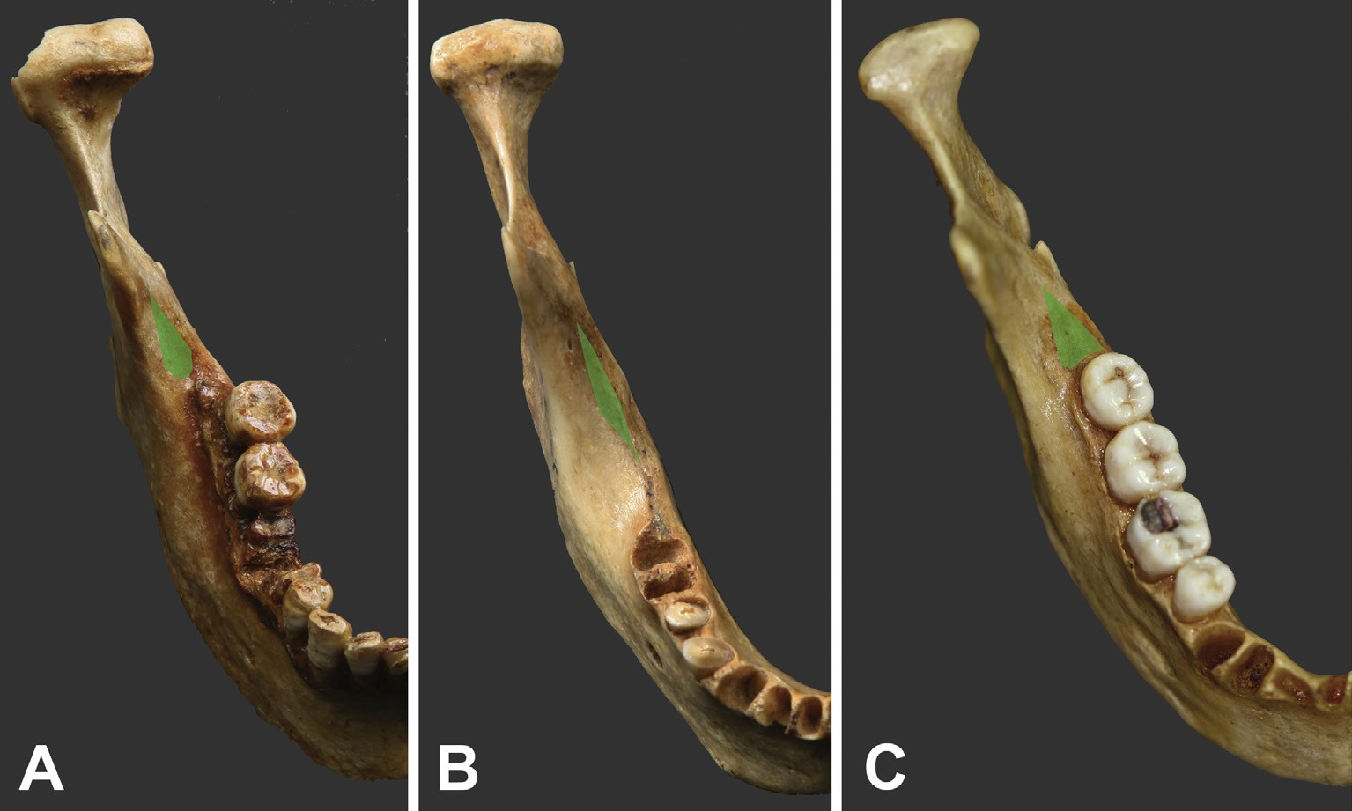

Figure 3 Classification of the retromolar triangle according to its shape (green): (A) drop form, (B) tapering form, and (C) triangular form.

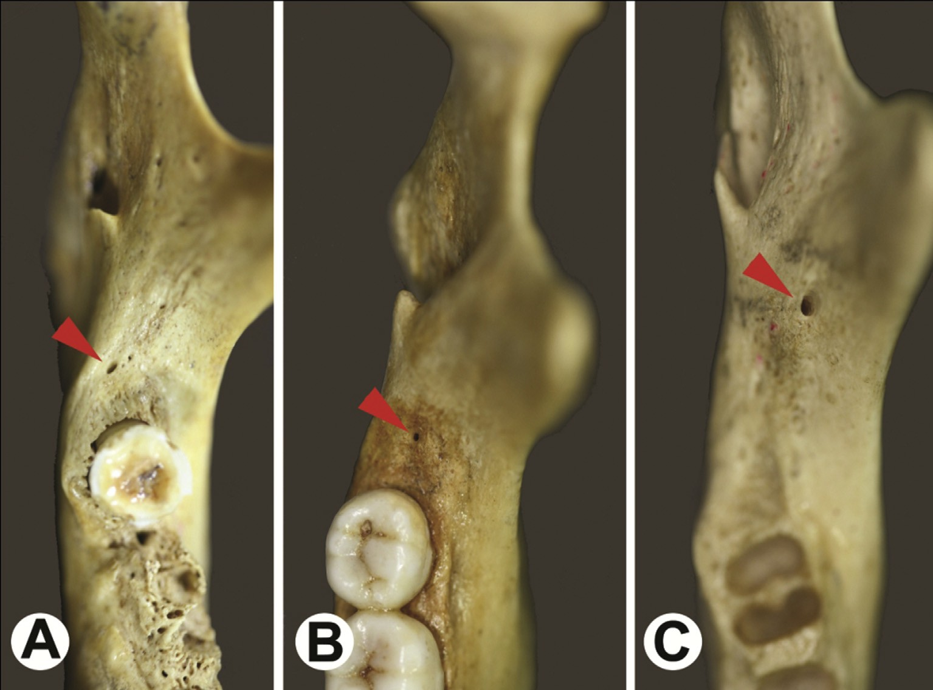

Figure 4 Photographs showing the retromolar foramen (RMF, red arrowheads). (A) RMF located in the retromolar foramen (RMT) and on the lingual side of the midsagittal line of the RMT. (B) RMF located in the RMT and on the midsagittal line of the RMT. (C) RMF located outside the RMT and on the buccal side of the midsagittal line of the RMT.

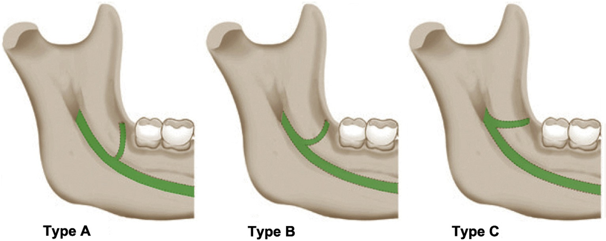

Figure 1 Schematic illustrations of the three types of the retromolar canal. Type A, a vertical course; Type B, a curved course; and Type C, a horizontal course.

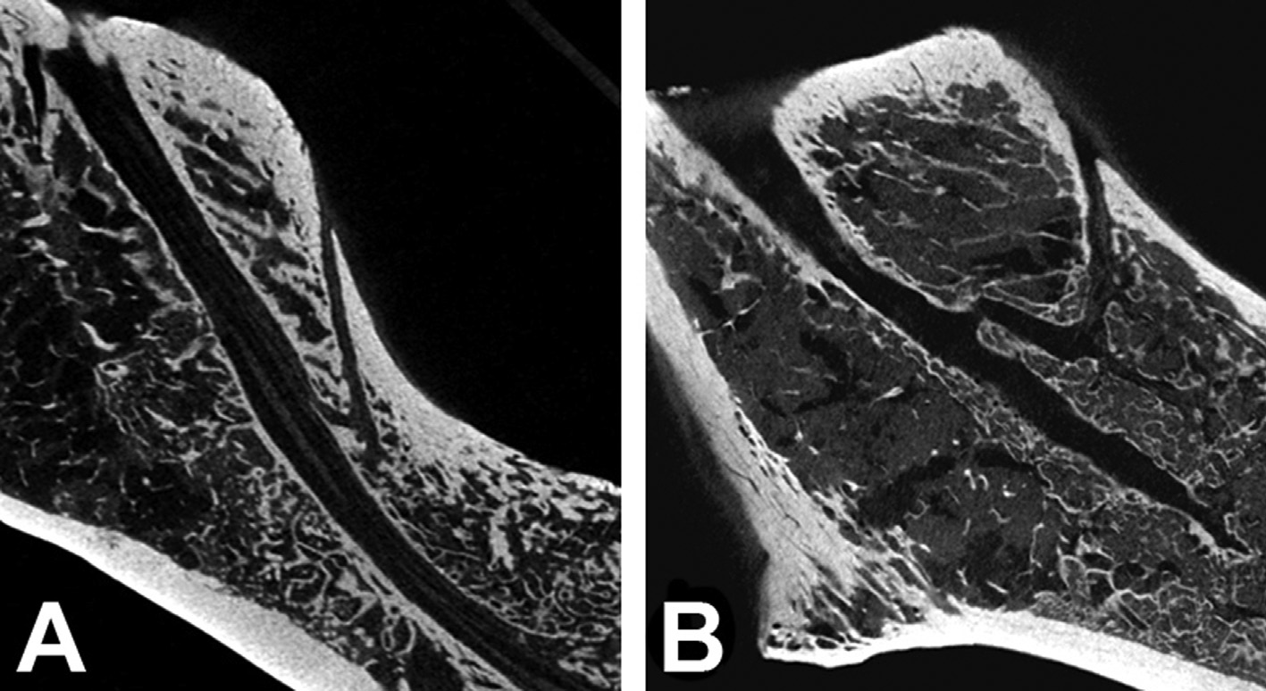

Figure 5 Classification and examples of the retromolar canal: (A) Type A, vertical course; and (B) Type B, curved course.

Lingual canal and foramina:

Sublingual and submental arteries run in lingual cnal. There is tremendous varations in their course and anastosmosis. Performing the dental implantation procedures in the anterior and posterior regions of the mandible can result in perforation of the lingual cortex, which could injure the arteries that lie within the lingual canal. If hemorrhage occurs, it could lead to life-threatening upper airway obstruction. Pre-surgical investigation to identify the diameter of the lingual foramina and canal as well as their distance from the alveolar process might be necessary to prevent hemorrhage for all patients.

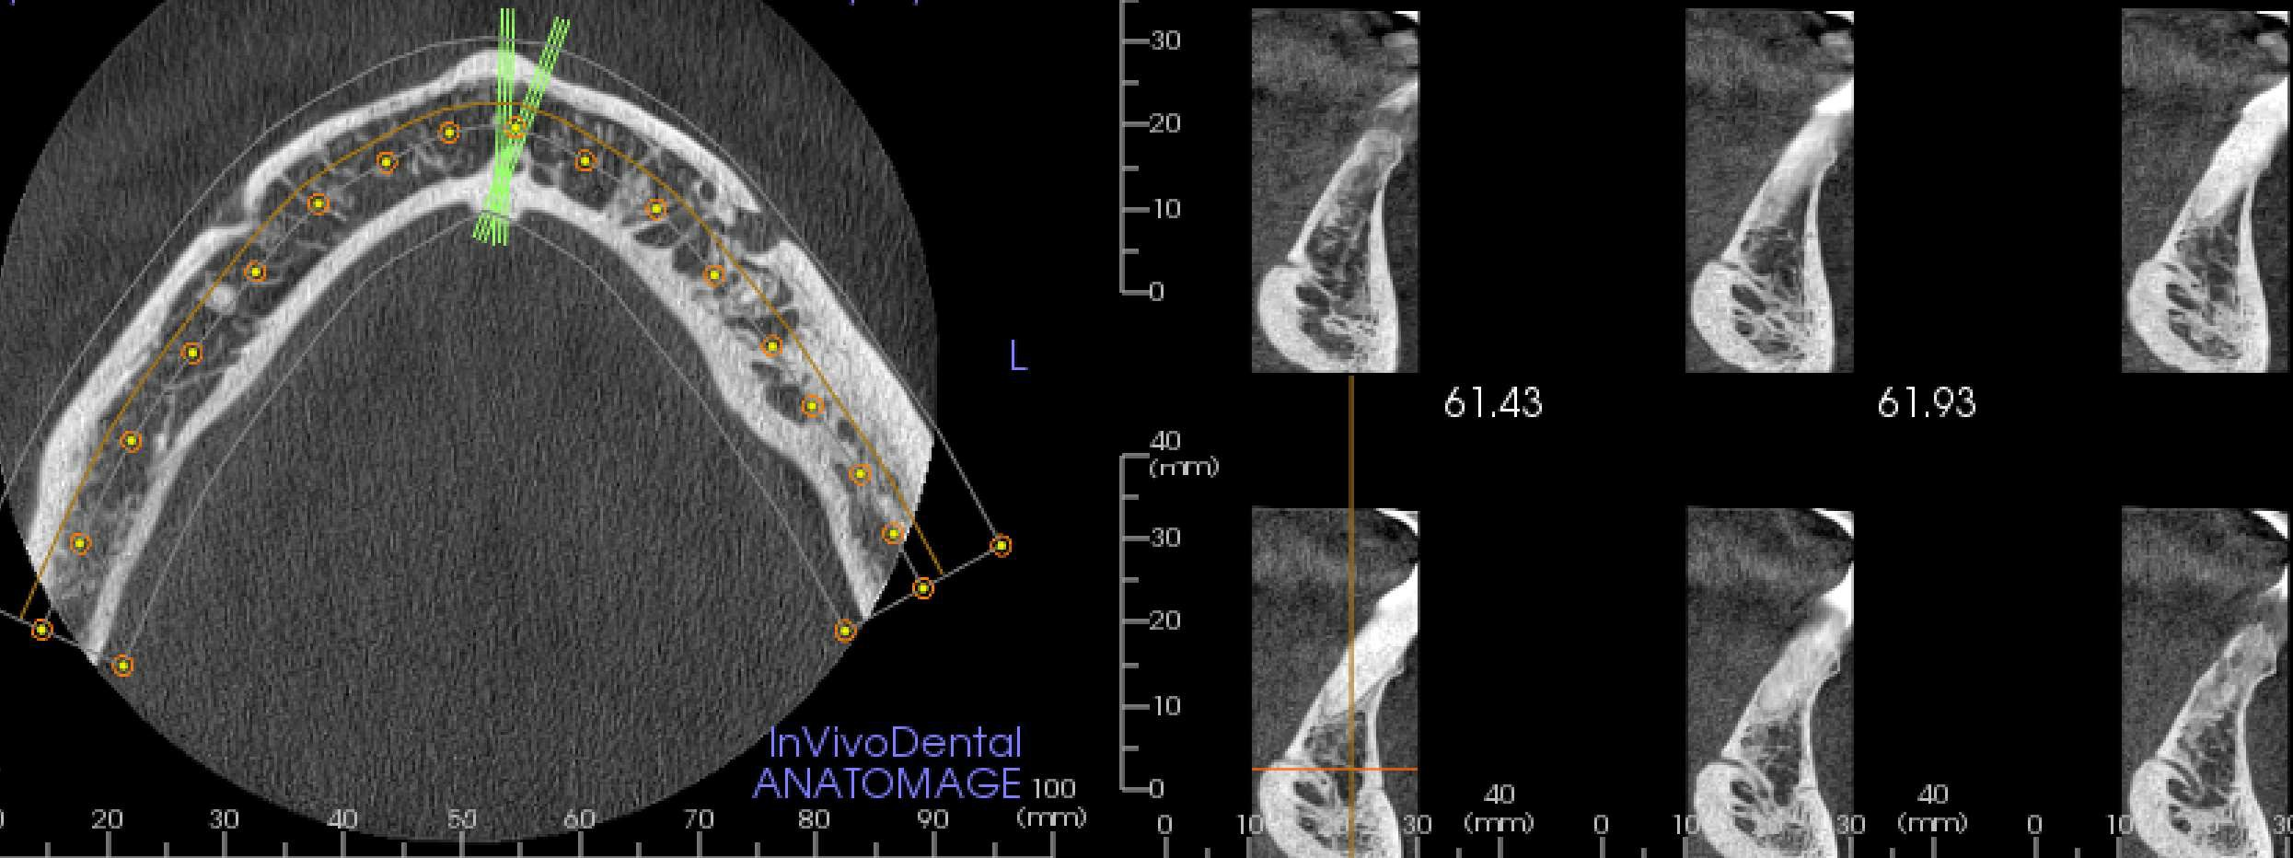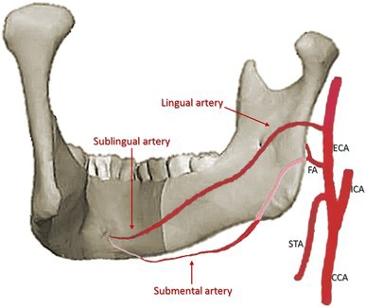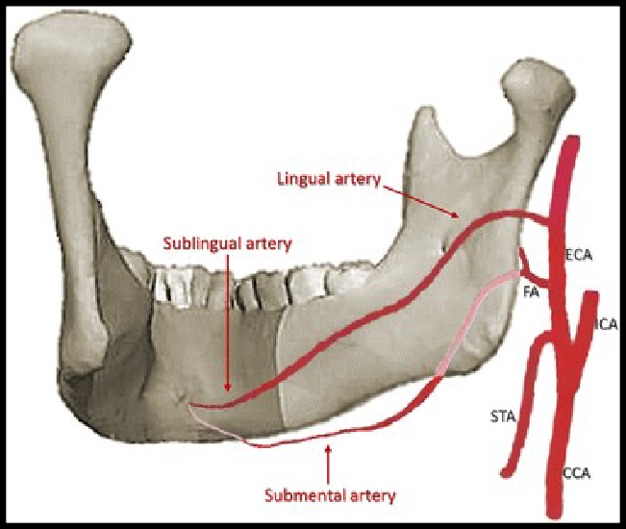

'/Users/zen/Library/Mobile Documents/com~apple~CloudDocs/Onedrive NHS IOW/Workstation companions/HNI/Dental Radiology/3 Paneer.pdf '

Arteries in dental CT:

Form cranial to caudal:

1. Descending palatine artery- terminates inferiorly into (posteriorly directed) lesser and (anteriorly directed) greater palatine artery. Greater palatine nerve runs along with Descending Palatine artery.
2. Posterior superior alveolar artery- inferiorly gives of Anterior Antral artery. Runs along with same named nerves.
3. Anterior superior alveolar artery. Runs along with same named nerves.
4. Posterior branch of Sphenopalatine artery.

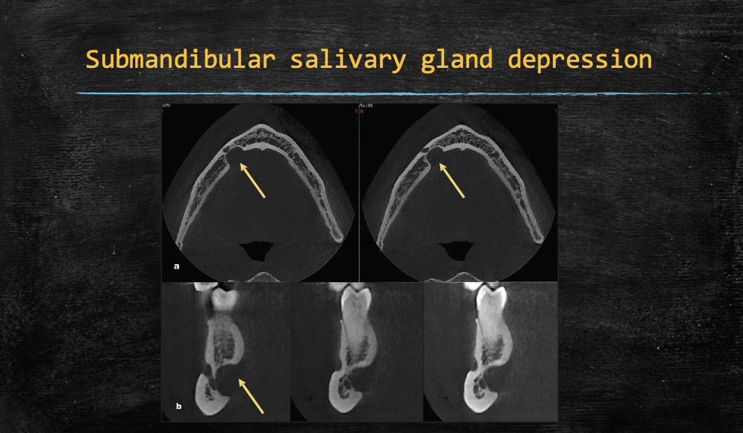

Nasopalatine and Incisiva foramina and Foramina Stenson :

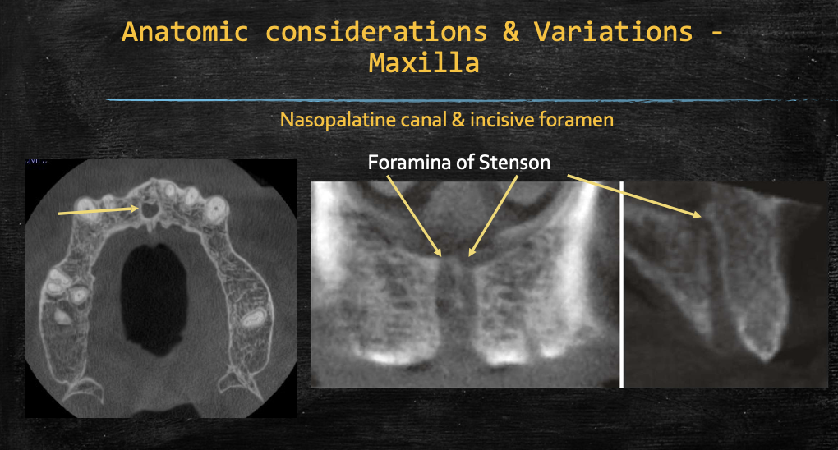

Cnal Sinosus   
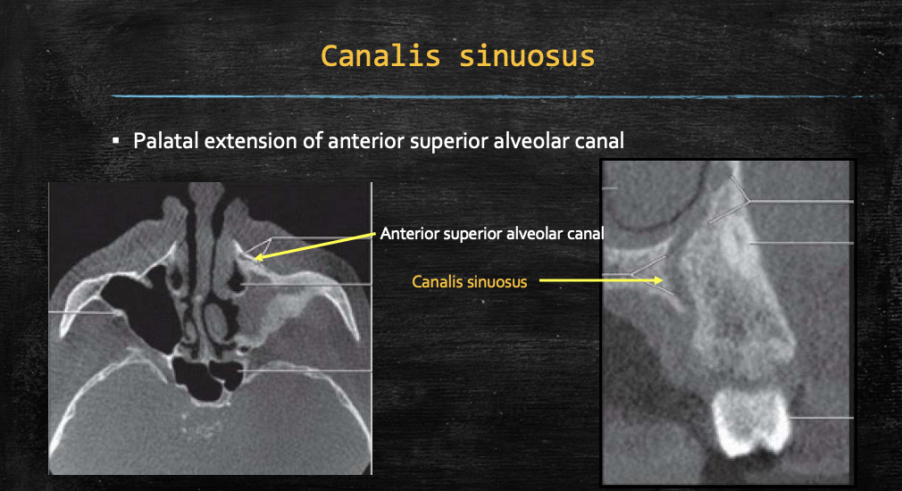

Prominent Superior aleveolar canal :

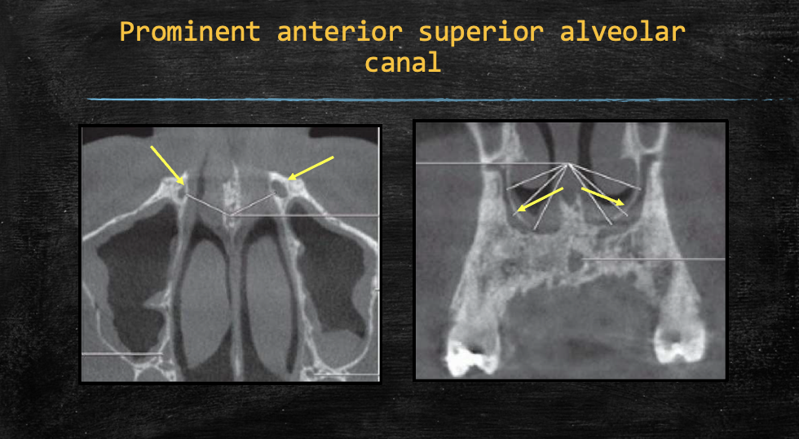

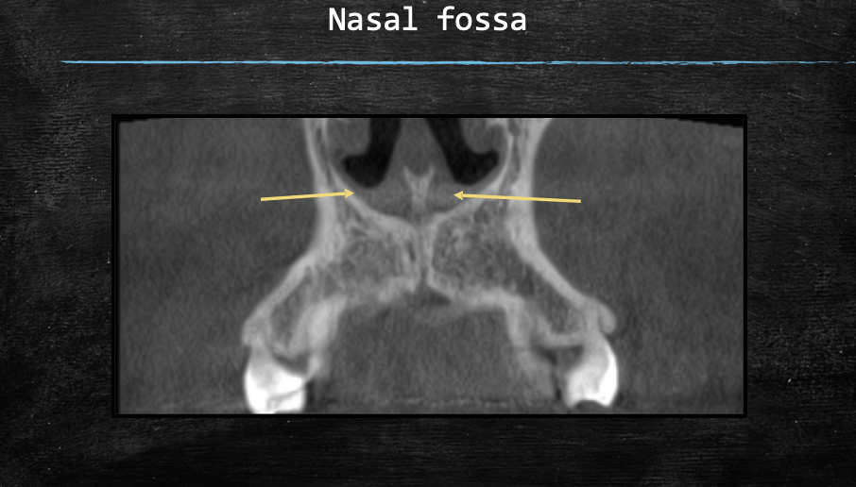

Buccal concavity :

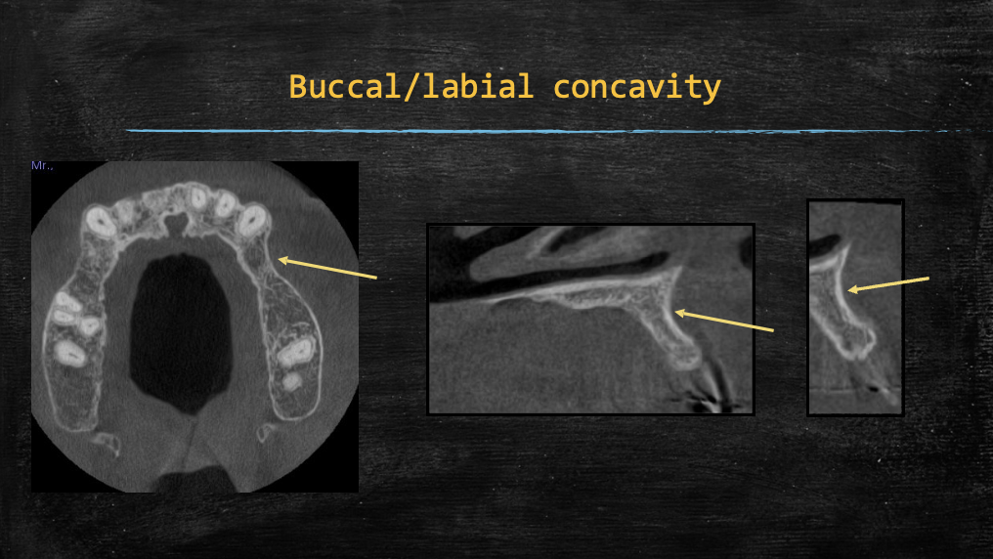

**CBCT measurements to facilitate Maxillary sinus lift:**

1. Cross sectional CBCT – location specific measurements to optimize access (3–4 mm above the apical base of the maxillary sinus through the buccal plate)
2. Sinus disease free or have minimal mucosal thickening (<3 mm)
3. Ostia patent
4. Posterior superior alveolar artery in the lateral antral wall should be identified and avoided during surgery.
5. Any condition leading to obstruction of ostium and drainage of the maxillary sinus such as localized mucosal thickening of the ostium and concha bullosa (pneumatized inferior turbinate) should be identified.

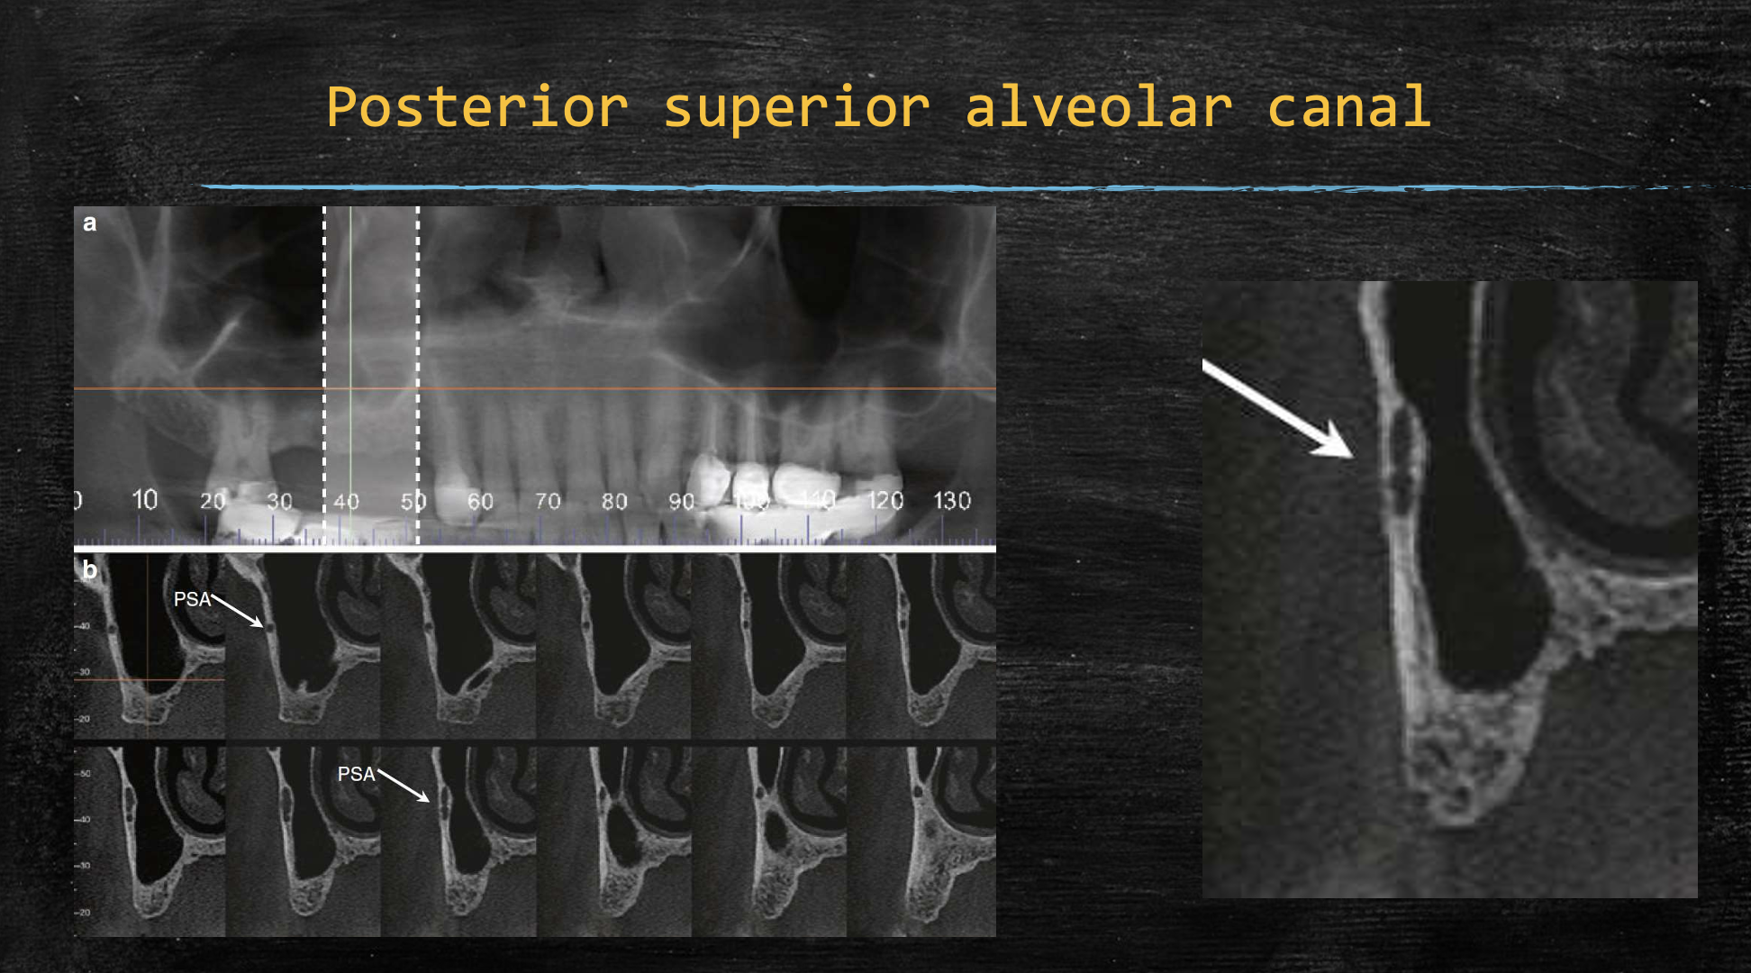

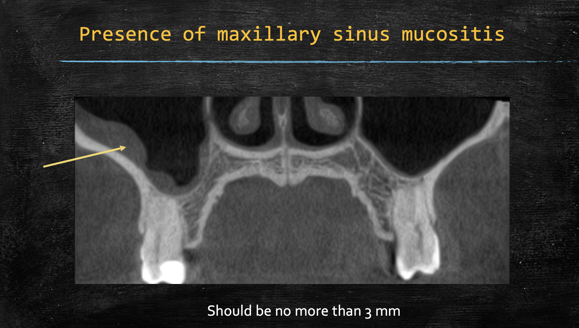

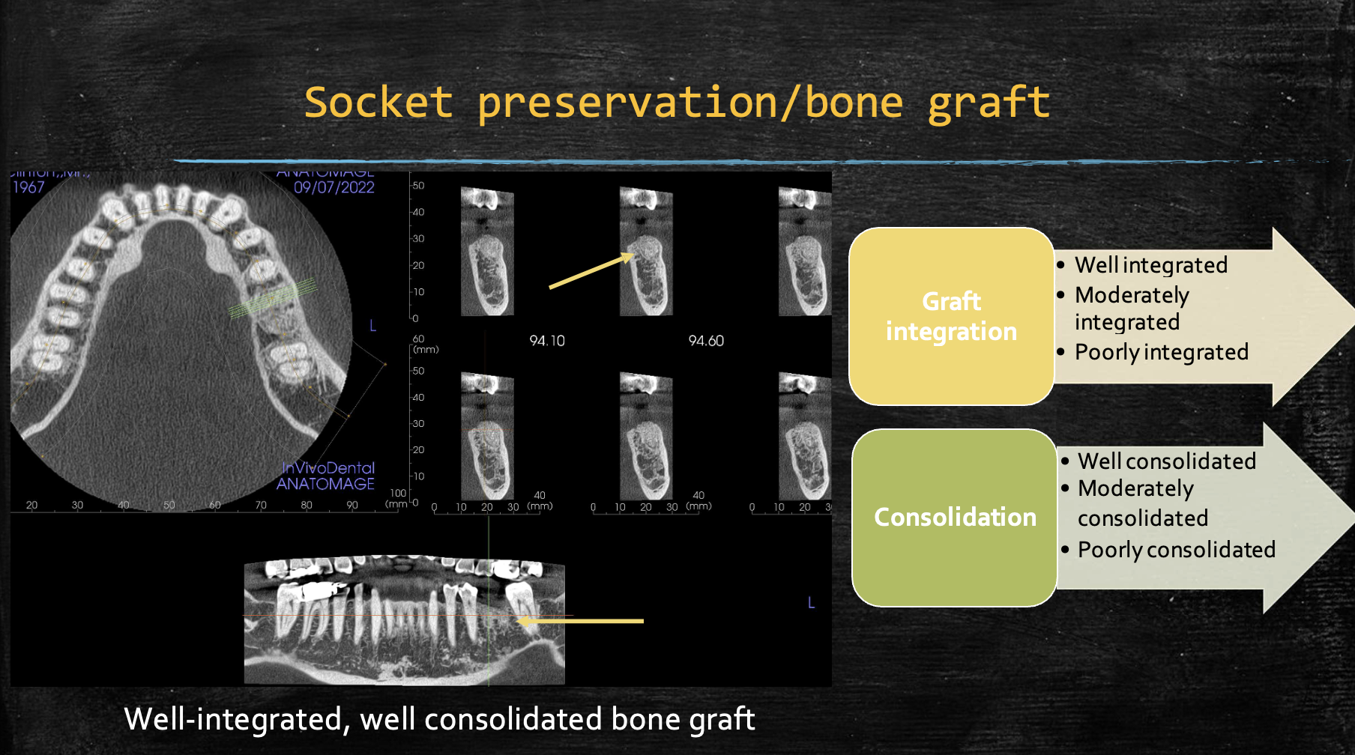

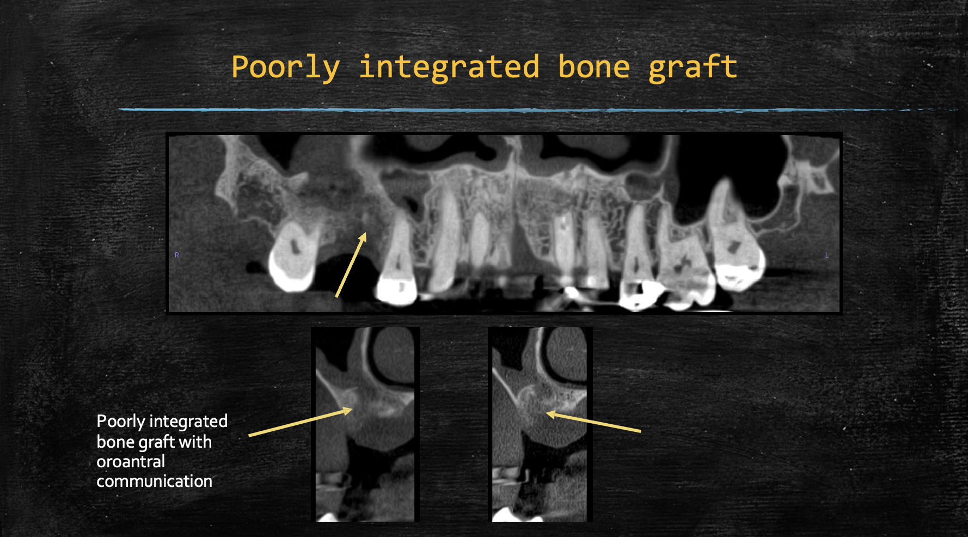

Dental Implant: